MORELLE
Geoffrey

Activiter CSS : Test de positionnement
------------------------------------------------------------------------------------------------------------------------
Exo1 :

HTML : CSS :
<!DOCTYPE html>  <head>  <meta charset="UTF-8">  <title>TP2CSS</title>  <link rel="stylesheet" href="main.css">  </head>  <body>  <div id="Baudeau">  <p>Baudeau</p>  </div>  <div id="Contenu">  <p>Contenu</p>  </div>  <div id="pied_de_page">  <p>Pied de page</p>  </div>  </body>  </html> | #Baudeau{  display: flex;  background-color: green;  height: 5vh;  justify-content: center;  align-items: center;  font-size: 250%;  }  #Contenu{  display: flex;  background-color: blueviolet;  height: 80vh;  justify-content: center;  align-items: center;  font-size: 250%;  }  #pied_de_page{  display: flex;  background-color: brown;  height: 5vh;  justify-content: center;  align-items: center;  font-size: 250%;  }
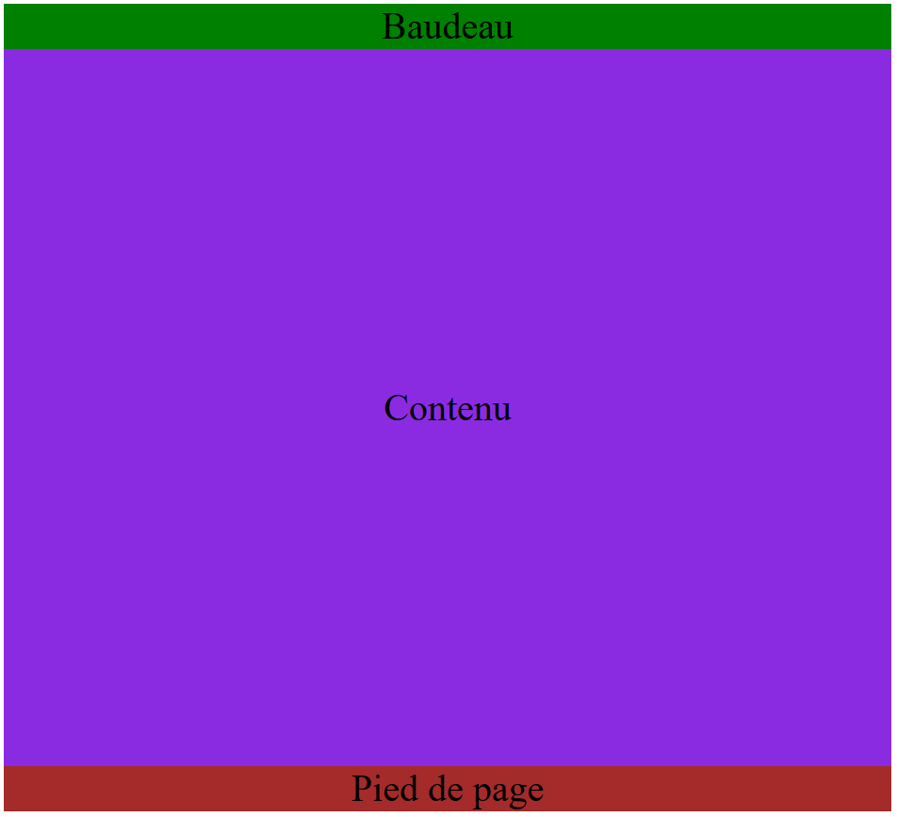
Résultat :

Exo 2 :

HTML : CSS :
<!DOCTYPE html>  <head>  <meta charset="UTF-8">  <title>TP2CSS</title>  <link rel="stylesheet" href="main.css">  </head>  <body>  <div id="Baudeau">  <p>Baudeau</p>  </div>  <div class="contenu">  <div id="menu">  <p>menu</p>  </div>  <div id="Contenu">  <p>Contenu</p>  </div>  </div>  <div id="pied_de_page">  <p>Pied de page</p>  </div>  </body>  </html> | #Baudeau{  width: 100%;  display: flex;  background-color: green;  height: 5vh;  justify-content: center;  align-items: center;  font-size: 250%;  }  .contenu{  display: flex;  flex-wrap: wrap;  }  #menu{  background-color: mediumslateblue;  display: flex;  justify-content: center;  align-items: center;  font-size: 250%;  flex-direction: column;  width: 15%;  height: 90vh;  }  #Contenu{  width: 85%;  display: flex;  background-color: blueviolet;  height: 90vh;  justify-content: center;  align-items: center;  font-size: 250%;  }  #pied_de_page{  width: 100%;  display: flex;  background-color: brown;  height: 5vh;  justify-content: center;  align-items: center;  font-size: 250%;  }
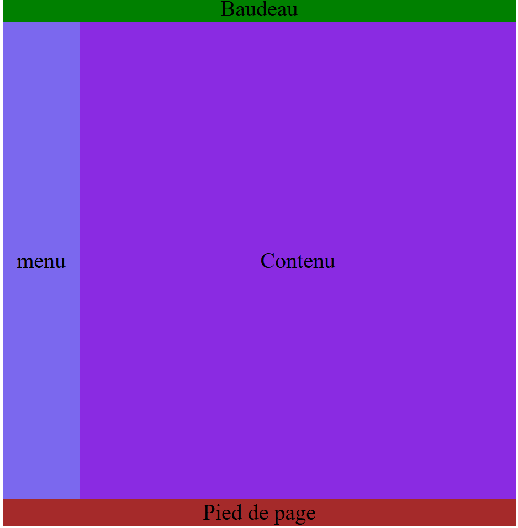
Résultat :

Exo 3 :

HTML : CSS :
<!DOCTYPE html>  <head>  <meta charset="UTF-8">  <title>TP2CSS</title>  <link rel="stylesheet" href="main.css">  </head>  <body>  <div class="container">  <div id="Bandeau">  <p>Bandeau</p>  </div>  <div class="container_menu">  <div id="menu_haut">  <p>menu haut</p>  </div>  <div id="menu_bas">  <p>menu bas</p>  </div>  </div>  <div class="contenu">  <div id="Contenu">  <p>Contenu</p>  </div>  <div id="news">  <p>news</p>  </div>  </div>  <div id="pied_de_page">  <p>Pied de page</p>  </div>  </div>  </body>  </html> | #Bandeau {  width: 100%;  display: flex;  background-color: green;  height: 5vh;  justify-content: center;  align-items: center;  font-size: 250%;  }  .container_menu{  display: flex;  flex-direction: column;  float: left;  width: 15%;  height: 90vh;  font-size: 250%;  }  #menu_haut {  display: flex;  background-color: fuchsia;  height: 50vh;  align-items: center;  justify-content: center;  }  #menu_bas {  display: flex;  background-color: yellow;  height: 50vh;  align-items: center;  justify-content: center;  }  .contenu{  display: flex;  justify-content: flex-end;  height: 100%;  }  #Contenu {  width: 100%;  display: flex;  background-color: blueviolet;  justify-content: center;  align-items: center;  font-size: 250%;  height: 90vh;  }  #news{  display: flex;  position: absolute;  background-color: chocolate;  width: 25%;  height: 25%;  justify-content: center;  align-items: center;  font-size: 250%;  }  #pied_de_page {  width: 100%;  display: flex;  background-color: brown;  height: 5vh;  justify-content: center;  align-items: center;  font-size: 250%;  }

Résultat :
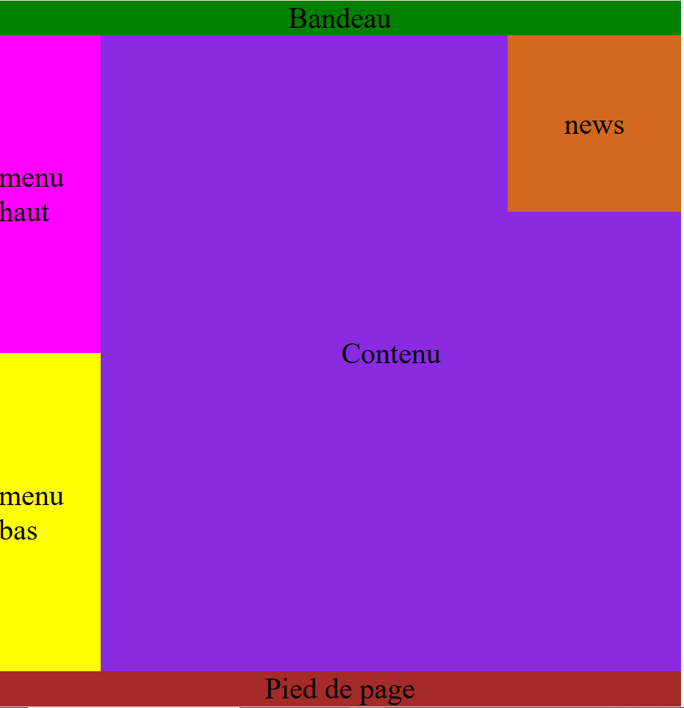
exo 4 :

